Guided Capstone Project Report

Using the data collected from snow resorts across US. Even though some of the data were removed due to being outliers, the total number of resorts were reduced to 266, which is still a generous amount of resorts to observe and analyze. From these data, I had created a linear-regression model to predict the weekend ticket prices, if other information were able to be provided. The model predicted Big Mountain Resort’s Adult Weekend ticket price to be $86, which is more than the actual Adult Weekend ticket price of $81. Since both the weekday and weekend adult ticket prices were $81, I’d recommend both of the ticket prices to be increased to $90.

Let’s take a look at a few figures to why I have come to this conclusion

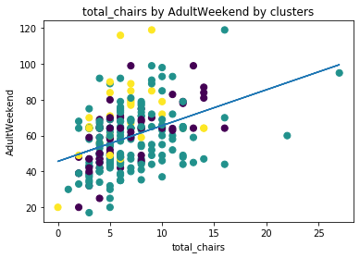

This scatter plot shows that, for most of the resorts, the more chair lifts a resort has, the higher its ticket prices. And if we take a look at the 14 total chairs column, we can see that for resorts with similar summit elevation to Big Mountain (teal dots), Big Mountain Resort actually has the lowest ticket price!

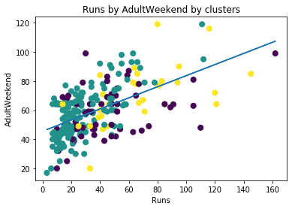

This scatter plot shows that, more runs also is more likely to have higher ticket price. Big Mountain Resort had a total of 105 runs, if we take a look at the linear regression line in this plot, we’re definitely below that line as well.

The top correlations of ticket prices were the following (in Descending order):

Runs, vertical_drop, fastQuads, SnowMaking, total_chairs

I have done the scatter plots of the above variables by adult weekend ticket price by clusters; most of them are already at a fitting point (slightly above regression line) when compared to other resorts with similar status e.g. same number of fastQuads.

I have also checked the scatter plot of the resorts’ open days from last year. It didn’t have much effect on the ticket price, and most of the resorts opened for around 120 days. Which, Big Mountain Resort is already doing, by opening 123 days last year.

To conclude, I highly recommend Big Mountain Resort to keep its projected open days to 120. But increase both its Adult Weekday and Adult Weekend ticket prices to $90; it was calculated by using the predicted ticket price from the model ($86) then add the 5% of its original ticket price ($81 x 5% = $4) as inflation.